HONG KONG INSTITUTE OF VOCATIONAL EDUCATION

**Laboratory 9: Unit Testing and Test Scripts**

**Module Intended Learning Outcome:**

On completion of the module, students are expected to be able to:

* Apply software testing techniques in various software development stages.

**TASK:**

1. **Create Project Lab09 for Junit Test**

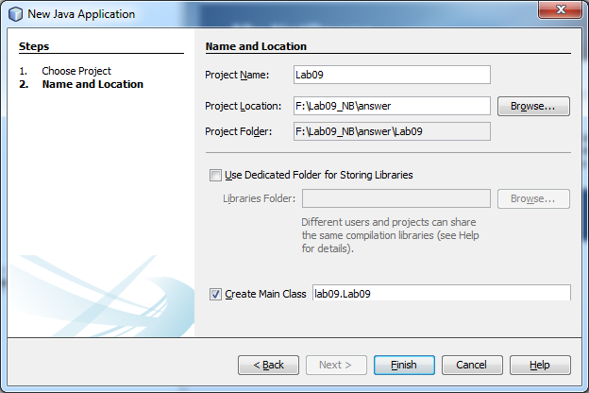

* 1. Import the given 3 java classes (IMoney.java, Money.java and MoneyBag.java) under package “junit\samples\money” to the src folder of the Lab09 project. (Copy folder junit & Paste in NetBeans)

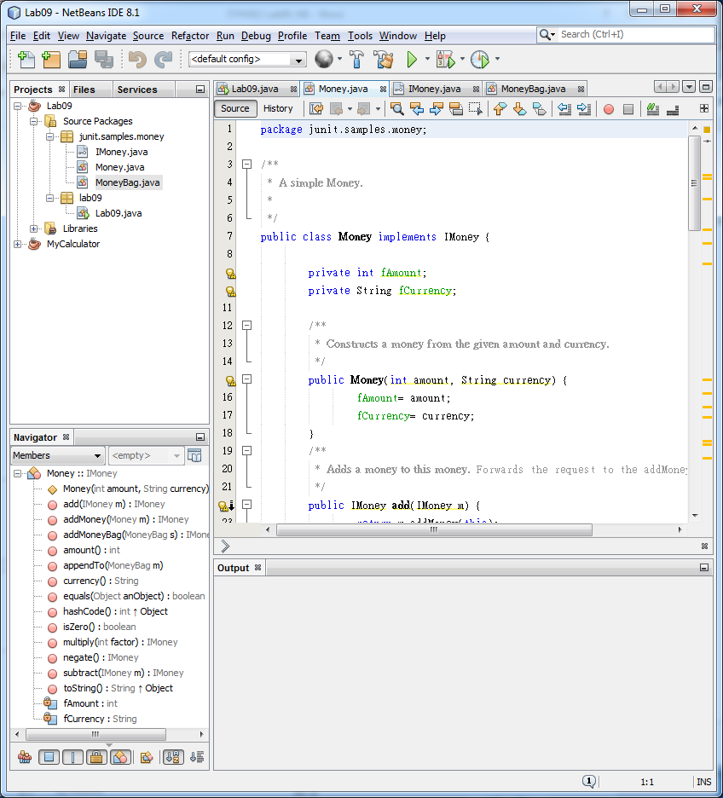

* 1. Add the **JUnit** library to the project, add **Hamcrest** library too.

Kt’s Hints: You may get this error if you have not add Hamcrest.

1. **Create Junit Test Case**
   1. Select project and right click to New a Junit Test Case

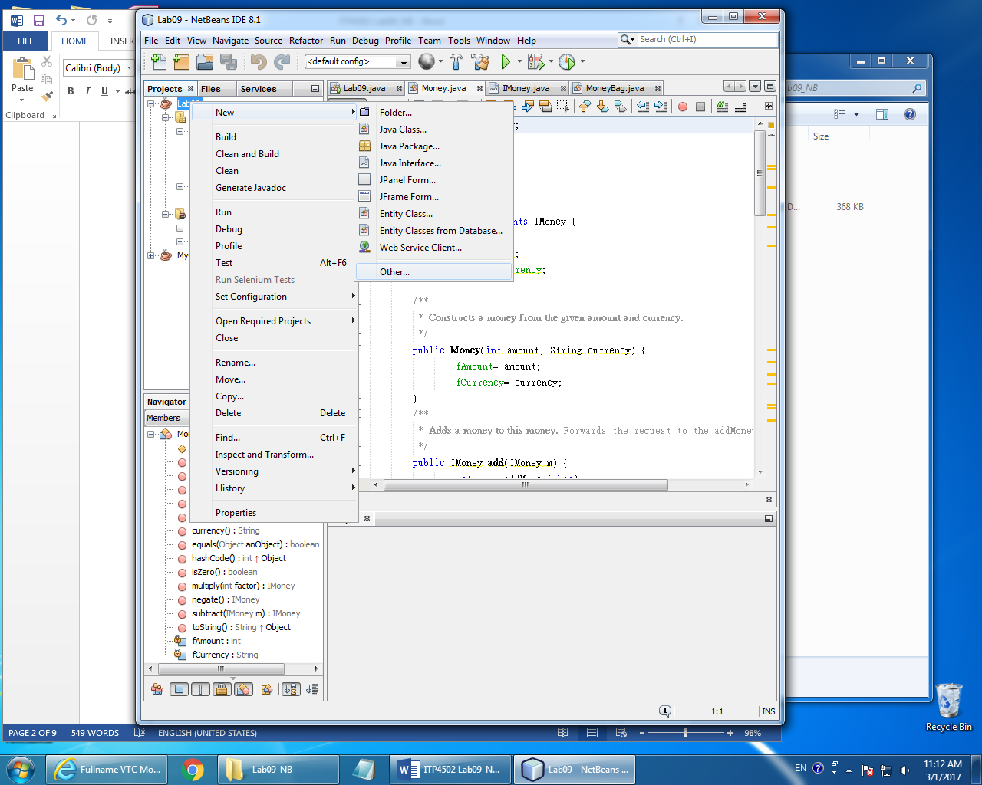

* 1. Select “New > Unit Tests > **Test for existing class**”

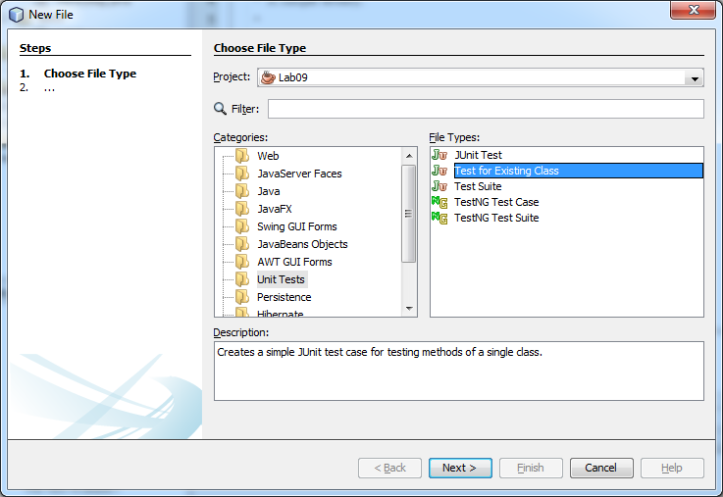

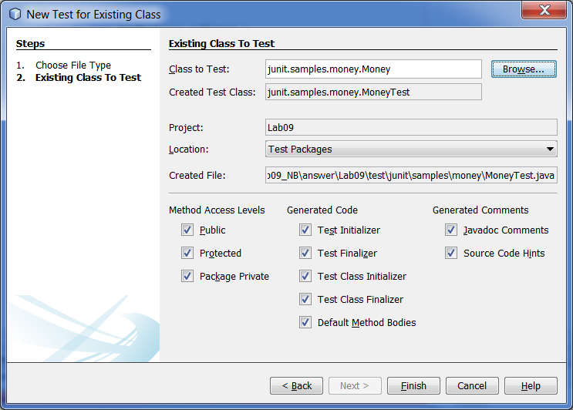

* 1. Run the tester MoneyTest.java, you will get lots of errors. It is normal.

* 1. Remove all test cases EXCEPT test cases for “**add**”, “**addMoney**”, “**isZero**”, “**multiply**”, “**negate**”, “**subtract**”.
  2. Remove the default contents of test methods: “**add**”, “**addMoney**”, “**isZero**”, “**multiply**”, “**negate**”, “**subtract**”. (i.e. delete the default code)
  3. Right click **MoneyTest.java**, select “**Test File**”, you should get:

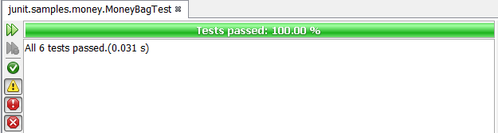

* 1. Note: import **org.junit.Assert;**
  2. Implement the Test Case Class as below source.

**private** Money f12CHF;

**private** Money f14CHF;

**private** Money f7USD;

**private** Money f21USD;

@BeforeClass

**public** **static** **void** setUpClass()

{

System.*out*.println("@setUpClass");

}

@AfterClass

**public** **static** **void** tearDownClass()

{

System.*out*.println("@tearDownClass");

}

@Before

**public** **void** setUp()

{

System.*out*.println("@setUp");

f12CHF= **new** Money(12, "CHF");

f14CHF= **new** Money(14, "CHF");

f7USD= **new** Money( 7, "USD");

f21USD= **new** Money(21, "USD");

}

@After

**public** **void** tearDown()

{

System.*out*.println("@tearDown");

}

/**

* Test method for {@link junit.samples.money.Money#add(junit.samples.money.IMoney)}.

*/

@Test

**public** **void** testAdd()

{

System.*out*.println("@testAdd");

// check that [12 CHF] + [14 CHF] = [26 CHF]

// with the assertEquals method of Assert class

// to be completed by you!

|  |
| --- |
| Money expected = new Money(26, "CHF");  Assert.assertEquals(expected, f12CHF.add(f14CHF)); |

}

/**

* Test method for {@link.junit.samples.money.Money#addMoney(

* junit.samples.money.Money)}.

*/

@Test

**public** **void** testAddMoney()

{

System.*out*.println("@testAddMoney");

// check that [7 USD] + [21 USD] = [28 USD]

// with the assertEquals method of Assert class

// to be completed by you!

}

/**

* Test method for {@link junit.samples.money.Money#isZero()}.

*/

@Test

**public** **void** testIsZero()

{

System.*out*.println("@testIsZero");

// check that [0 USD] is Zero

// with the assertTrue method of Assert class

// to be completed by you!

// check that [12 USD] is not Zero

// with the assertFalse method of Assert class

// to be completed by you!

}

/**

* Test method for {@link junit.samples.money.Money#multiply(int)}.

*/

@Test

**public** **void** testMultiply()

{

System.*out*.println("@testMultiply");

// check that [14 CHF] *2 == [28 CHF]

// with the assertEquals method of Assert class

// to be completed by you!

}

/**

* Test method for {@link junit.samples.money.Money#negate()}.

*/

@Test

**public** **void** testNegate()

{

System.*out*.println("@testNegate");

// check that [14 CHF] negate == [-14 CHF]

// with the assertEquals method of Assert class

// to be completed by you!

}

/**

* Test method for {@link junit.samples.money.Money#subtract(junit.samples.money.IMoney)}.

*/

@Test

**public** **void** testSubtract()

{

System.*out*.println("@testSubtract");

// check that [14 CHF] - [12 CHF] == [2 CHF]

// with the assertEquals method of Assert class

// to be completed by you!

}

**Note: Make sure that the package containing class “Assert” has been imported.**

**Execute Test Case by Junit**

* 1. After completed the adding the testing code, then we should try to run.
  2. Right the “**MoneyTest.java**”, Select “Test File”
  3. You should see the test result.

